Section I
75 marks

Part A – 15 marks
Attempt Questions 1-15
Allow about 30 minutes for this part

Use the multiple choice answer sheet on page 7

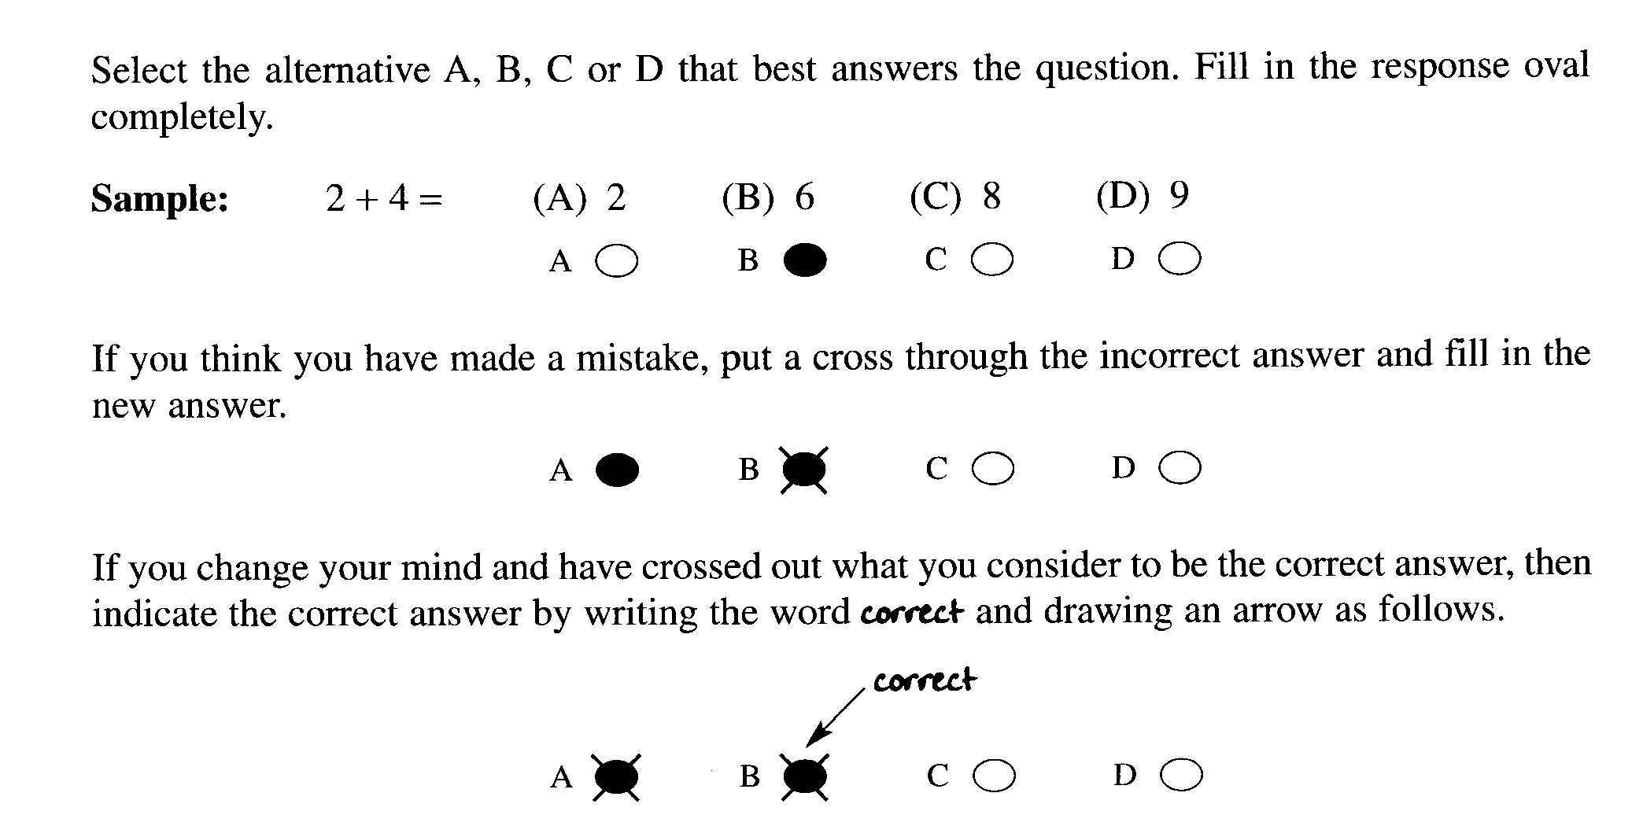

________________________________________________________________________________
1. Consider the following reactions:

(i) Ag⁺ + Cl⁻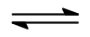 AgCl

(ii) CH₄ + O₂ → CO₂ + 2 H₂O

(iii) Mg + 2 HCl → MgCl₂ + H₂

(iv) Mg(OH)₂ + HCl → MgCl₂ + H₂O

Which of the reactions can be considered an acid-base reaction(s).

(A) (i), (ii), (iii), (iv)

(B) (i), (iii) and (iv) only

(C) (iv) only

(D) (i) only

2. Which of the following equations represent the Haber process?

(A) N + 3H → NH₃ ΔH = - 91 kJ

(B) N₂ + 3H₂ → 2NH₃ ΔH = -91 kJ

(C) N₂ + 3H₂ 2NH₃ ΔH = +91 kJ

(D) N₂ + 3H₂ 2NH₃ ΔH = -91 kJ

3. An unknown solution may contain one or more of the following ions: Mg²⁺, SO₄²⁻, CO₃²⁻, Pb²⁺, Cl⁻
The solution gave a white precipitate with Ba(NO₃)₂ but no reaction with H₂SO₄.

Which of the ions may be present ?

(A) Mg²⁺ and Cl⁻

(B) Pb²⁺ and Cl⁻

(C) Mg²⁺ and SO₄²⁻

(D) Mg²⁺ and CO₃²⁻

4. Consider the following haloalkane:

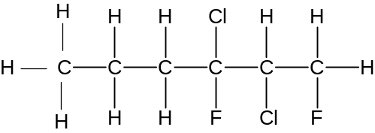

Which of the following is an isomer of the compound ?

(A) 1,1-dichloro-2-fluorohexane

(B) 1,2,5-trichloro-2-fluorohexane

(C) 1,3-dichloro-2,3-difluorohexane

(D) 2,3-dichloro-1,3-difluorohexane

5. A chemist wants to test for the presence of iron (III) ions in a water sample collected outside a
factory. Which anion could be used to test for the presence of iron (III) ions in the water?

(A) SO₄²⁻

(B) NO₃⁻

(C) OH⁻

(D) Cl⁻

6. What is the product of adding bromine water to 2-hexene?

(A) 2,3-dibromohexene

(B) 2,3-dibromohexane

(C) 1,2-dibromohexane

(D) 1,2-dibromocyclohexene

7 Where on the Periodic Table would you most likely find elements which form basic oxides?

(A) Group 1

(B) Group 6

(C) Period 2

(D) Period 3

8. Which elements on the Periodic Table have radioisotopes?

(A) Only those elements after uranium.

(B) Only the actinides.

(C) Only elements with unstable proton-neutron ratio.

(D) Only metallic elements

9. A student constructed a galvanic cell using two different metals and electrolytes of the
nitrates of the metals, under standard conditions.

Which combination of metals would give the greatest potential difference?

(A) copper and silver

(B) manganese and silver

(C) zinc and copper

(D) magnesium and zinc

10. The molar heat of combustion of propane is given in the data book as 2200 kJ mol⁻¹.
What does this mean?

(A) 1 g of propane releases 2200 kJ of heat

(B) 44 g of propane releases 2200 kJ of heat

(C) 1 g of propane absorbs 2200 kJ of heat

(D) 44 g of propane absorbs 2200 kJ of heat

11. Which of the following is a common natural source of sulfur dioxide in the atmosphere?

(A) The action of sunlight on S and O₂

(B) Smelting metal ores

(C) Soil bacteria

(D) Volcanoes

12. Which of the following may be used as a catalyst in esterification?

(A) H₂SO₄

(B) C₂H₅OH

(C) CH₃COOH

(D) H₂O

13. What is the name of the ester given below?

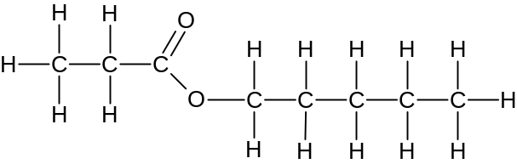

(A) butyl pentanoate

(B) pentyl butanoate

(C) propyl pentanoate

(D) pentyl propanoate

14 A soft drink may be decarbonated by heating. In observing the results, the equilibrium between
gaseous and dissolved carbon dioxide can be examined.

CO₂ (g) CO₂ (aq)

What conclusion can be drawn about this reaction?

(A) The forward reaction is exothermic.

(B) Only the reverse reaction rate is increased with heating.

(C) Heat is absorbed in the reaction shown above.

(D) Only the forward reaction rate is increases with heating.

15. Which correctly describes the relationship between an acid and its conjugate base?

(A) They are ions of opposite charge.

(B) They both contain H atom.

(C) They neutralize each other to form a salt.

(D) They have formulae that differ by a proton.

Student Number …………………………

Section I Marks-----/15
Part A

Multiple Choice Answer Sheet

1. A  B  C  D 

2. A  B  C  D 

3. A  B  C  D 

4. A  B  C D 

5. A  B  C  D 

6. A  B  C  D 

7. A  B  C  D 

8. A  B  C  D 

9. A  B  C  D 

10. A  B  C  D 

11. A  B  C  D 

12. A  B  C  D 

13 A  B  C  D 

14. A  B  C  D 

15. A  B  C  D 

JAMES RUSE AGRICULTURAL HIGH SCHOOL
2006 CHEMISTRY TRIAL HSC EXAM Student Number …………………………

Section I (continued)

Part B - 60 marks
Attempt Questions 16 to 28.
Allow about 1 hour and 45 minutes for this part

Answer the questions in the spaces provided

Show all relevant working in questions involving calculations

Marks
Question 16 ( 5 marks)

A buffer is known to contain two of these substances:

sodium dihydrogen phosphate sodium hydrogen phosphate
ethanoic acid sodium ethanoate

(a) Define a buffer 1

A solution that contains comparable amounts of a weak acid and its conjugate base and
which is therefore able to maintain an approximately constant pH even when significant
amounts of strong acid or base are added to it.

(b) Using an equation, explain how the substances can be used as a buffer.
2
CH₃COOH (aq) + H₂O(l) CH₃COO –(aq) + H₃O⁺(aq) (1 mark)

When an acid (H₃O⁺) is added to the buffer solution, the ethanoate ion combines with the
hydronium ion, in effect, shifting the equilibrium to the left, reducing the hydronium
concentration.
When a base is added, the OH⁻ combines with the hydronium, shifting the equilibrium to the
right to replenish the hydronium which combined with the OH⁻, maintaining the pH.

(c) Use balanced ionic equations to demonstrate how one of the above compounds can behave
as an amphiprotic substance. 2

HPO₄²⁻ + H₃O⁺ H₂PO₄⁻ + H₂O as a base (1 mark)

HPO₄²⁻ + OH⁻ PO₄³⁻ + H₂O as an acid (1 mark)

Marks
Question 17 (8 marks)

Sulfate in fertilizer may be analysed gravimetrically by precipitating the sulfate with barium ion
and weighing the sulfate produced after filtering and drying. To test the technique, which is
exactly what YOU did in the lab, a group of students performed the analysis on pure ammonium
sulfate. They obtained the following results.:

Mass of sample of ammonium sulfate: 2.34 g

Mass of filter paper: 0.203 g

Mass of filter paper + ‘dried’ precipitate: 4.65 g

(a) Calculate:

(i) the theoretical percentage of sulfate in ammonium sulfate 2

Answer:
Criteria | Mark
Correct formula for ammonium sulfate and correct answer | 2
Incorrect formula for ammonium sulfate but correct equation for theoretical percentage | 1

(ii) the experimental percentage of sulfate in ammonium sulfate 3

mass of BaSO₄ = 4.65 g – 0.203 = 4.447 g
mole of SO₄²⁻ = mole of BaSO₄ = 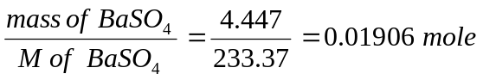(1 mark)
mass of SO₄²⁻ = 0.01905 x M sulfate = 1.83 g (1 mark)

Experimental percentage = 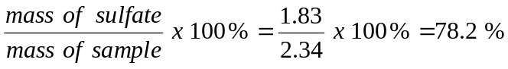 (1 mark)

(b) Assess the accuracy of the above determination. Identify and explain two possible sources
of error that can contribute to this particular discrepancy. 3

The analysis is inaccurate by about 6%. This is more than the normal expected error in chemical
analyses: Two reasons for a higher value are:
(a) The BaSO₄ was not dried properly. Moisture in the BaSO₄ precipitate increases the mass of the precipitate and hence calculated as BaSO₄
(b) The precipitate was not washed properly to remove excess BaCl₂. This increased
the mass of the ‘BaSO₄ ‘ precipitate.
Section I – Part B (continued) Student Number ………………….

Marks
Question 18 (6 marks)

The graph shows the variation in percentage yield of the product with pressure at various
temperatures for the Haber process.

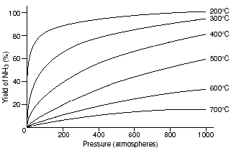

(a) Based on the graph, what conditions of temperature and pressure give the best yield for
this process? Justify your answer. 2

According to the graph, the best conditions to obtain maximum yield is between
800 - 1000 atm of pressure and 200 ⁰C . at this temperature and pressure, the yield is
almost 100 %. (2 marks)

(b) In industry, the conditions usually used are 400 ºC and 500 atm pressure. Explain the
reason(s) for the use of these conditions. 2

These are compromise conditions. The higher temperature than the optimum (200⁰C)
is adapted to hasten the attainment of equilibrium. Use of a lower temperature may maximise
yield but will be slow to attain equilibrium. The lower pressure is for economic considerations
as well, since, high pressure equipment are more expensive and are also expensive to run.

(Both temperature and pressure must be dealt with to get the 2 marks

(c) Identify the chemical composition of the catalyst used in this reaction and explain its role. 2

A catalyst (Fe₃O₄ – Fe) magnetite (surface reduced to Fe) is a catalyst used for the Haber
process. A catalyst enables the process to use a moderate temperature and still maintain
a reasonable rate of reaction. The catalyst lowers the activation energy for this reaction by
serving as a surface on which the reaction can occur efficiently.

1 mark for mentioning a catalyst and 1 mark for the role of the catalyst in
maintaining a reasonable rate.

Marks
Question 19 (5 marks)

A group of students were assigned to determine the copper ion content of a certain brand
of spring water. They prepared a series of standard copper ion solutions in distilled water
and analysed the standard solutions and the undiluted spring water with the AAS
instrument. They also tested some distilled water which they used to prepare the standard
solutions. The results are given below:

Solution | Cu²⁺ion concentration (ppm) | Absorbance
Standard 1 | 1.0 | 0.0521
Standard 2 | 2.0 | 0.0634
Standard 3 | 4.0 | 0.1205
Standard 4 | 6.0 | 0.1834
Standard 5 | 8.0 | 0.2467
Spring water | unknown | 0.0412
distilled water | unknown | 0.0501

(a) Construct a well labelled calibration curve for this determination. 3

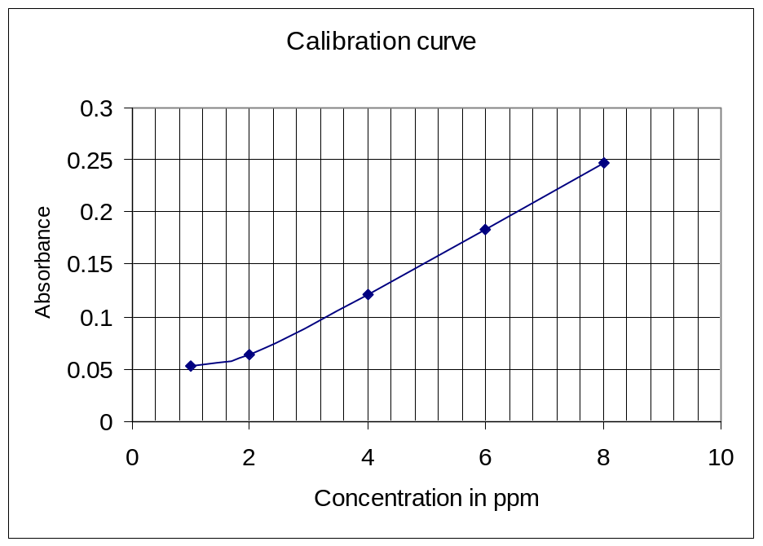

Criteria | Mark
proper orientation of graph (dependent/independent variable) | 1
labelled axes with correct units/proper scaling | 1
correct plotting | 1

Section I – Part B (continued) Student Number ………………….
Marks

(b) Comment on the validity of the distilled water as a control. 2

The distilled water is not valid as a control because it gives an absorbance reading which is
higher than the absorbance reading for the spring water.

Question 20. (2 marks)

Identify and describe two everyday uses of indicators. 2

Possible answer:

- Indicators may be used to test the pH of swimming pools. Pool test kits using a certain indicator (phenol red) ensures that pool pH is within the accepted level of acidity (pH 7.2 – 7.6).
- Soil pH testing allow farmers to determine the suitability of the soil for certain crops

Question 21 (8 marks)

Compare addition and condensation polymers using named examples of each type of polymer. 8
- Addition polymer: polyethene, monomer = ethene (1 mark)
Condensation polymer: cellulose, monomer = glucose (1 mark)

- Addition polymerization- long chain molecules produced by small monomer molecules
adding together without the loss of any atoms. The double bond
“opens out” to form single bonds with neighbouring molecules. (1mark)
- Condensation polymerization- a long chain molecule produced from smaller molecules
(monomers) via the removal of a small molecule, in this case,
water. (1 mark)
Reactions: (2 marks)
Addition polymerization

n CH₂=CH₂ → ⎯ (CH₂ - CH₂ )_{n} ⎯

Condensation polymerization

n (HO – C₆H₁₀O₄ – OH) → H ⎯(O- C₆H₁₀O₄)_{n}⎯OH + (n-1) H₂O

Uses: (2 marks)

polyethene – making milk bottles, soft toys, cling wrap, rubbish bins etc

cellulose - major structural component of plant material or biomass (strengthens cell walls)
using cellulose to make ethanol for energy production etc.
Section I – Part B (continued) Student Number ………………….
Marks

Question 22 (6 marks)

Ethylene can be transformed into many useful substances other than plastics.

(a) Complete the table for two substances derived from ethene other than plastics 4

Name of useful substance | Use
ethanol | fuel, solvent (1 mark)
ethylene glycol | antifreeze (1 mark)

(b) Write a balanced chemical equation to describe the formation of one of the substances
listed in (a). 2

C₂H₄(g) + H₂O(l) 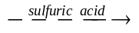 C₂H₅OH (aq)

Criteria | Mark(s)
balanced equation including any conditions | 2

Marks
Question 23 (8 marks)

A student made these observations after doing the reactions:

- Metal X did not react with 1 molL⁻¹ solution containing Y²⁺ ions.

- Metal Y in a 1 molL⁻¹ solution of Z²⁺ ions formed metal Z

- Metal Z did not react with a 1 molL⁻¹ solution of X²⁺

(a) List the metals X, Y and Z in order of increasing ease of oxidation. 1

Z, X, Y (1 mark)

(b) List the ions in order of increasing ease of reduction. 1

Y²⁺, X²⁺ , Z²⁺ (1 mark)

(c) Draw a labelled diagram of an electrochemical cell made with two of the above metals
that would produce the greatest voltage. Indicate on your diagram which is the anode and
cathode and the direction of electron flow. 5

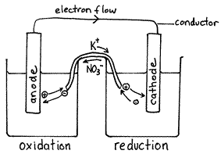

Y (anode) in Y²⁺ _{(aq)} Z cathode in Z²⁺_{(aq)}

Marking Scheme: 1 mark each for
- correct choice of Y and Z;
- Y labeled anode in Y²⁺ ;
- Z labeled cathode in Z²⁺,
- salt bridge labeled;
- electron flow correct,

(d) Write a balanced net ionic equation for the chemical reaction. occurring in the
electrochemical cell

Y(s) + Z²⁺(aq) → Z(s) + Y²⁺(aq) (1 mark)
1

Section I – Part B (continued) Student Number ………………….
Marks

Question 24 ( 5 marks)

Consider the properties of three acids.

Acids | pH
0.1 molL⁻¹ acetic acid | 2.9
0.1 molL⁻¹ citric acid | 2.1
0.1 molL⁻¹ hydrochloric acid | 1.0

(a) Give the systematic name for citric acid 1

2-hydroxypropane-1,2,3-tricarboxylic acid

1 mark for the correct name

(b) Explain the difference in pH between the three acid solutions. 2

Marking Criteria | Marks
Explains the complete and incomplete ionisation of acids and links to pH | 2
Identifies HCl as a strong acid and acetic and citric acids as weak acids | 1

(c) Calculate the pH after 100mL of 0.1 molL⁻¹ hydrochloric acid solution is diluted
by the addition of 400mL of distilled water. 2

Possible answer:
c1v1 = c2v2

0.1 x 0.1 = c2 x 0.5

c2 = 0.02 molL⁻¹

pH = - log [H⁺]

= 1.7

Correctly calculates pH with relevant working,( 1 mark.)
Marks
Question 25 (3 marks)

A source of sulfur dioxide in the atmosphere is the burning of coal in power stations.
Calculate the volume of sulfur dioxide released at 25⁰C and 100kPa when 10.0 million kg
of coal containing 0.01% sulfur, is burnt. 3

Calculation:

mass of sulfur = 10⁶ g

mol of sulfur = 3.12 x 10⁴ mol

mol of sulfur = mol SO₂

volume SO₂ = mol x 24.79

= 7.73 x 10⁵ L

Marking Criteria | Marks
Correct answer showing all relevant working | 3
2 of those below | 2
Multiplies incorrect moles by 24.79 or  Correct equation or  Correct calculation of mol of sulfur or  Correct calculation of mass of sulfur | 1

Question 26 (4 marks)

An ester is prepared in the laboratory by refluxing a mixture of appropriate alkanol and
alkanoic acid using acid catalysis.

Identify two potential safety hazards and describe the experimental procedures that may be used to minimize these hazards in the preparation of the ester. 4

Possible answer
- The components being heated are flammable. The reflux condenser allows the flammable
components to condense and return to the reaction vessel.
- Build-up of gas pressure. The top of the condenser is open so that no build -up of pressure can
take place.

Marking Criteria | Marks
Two hazards identified and safety steps described to minimize the hazard | 4
Two hazards identified and one safety step described to minimize the hazard | 3
Two hazards identified or one hazard and one safety step described | 2
One hazard identified | 1

2006 JAMES RUSE AGRICULTURAL HIGH SCHOOL TRIAL HSC EXAMINATION

Chemistry

Section II

25 marks

Attempt question 27
Allow about 45 minutes for this section

Answer the question in a writing booklet. Extra writing booklets are available.
Show all relevant working in questions involving calculations.

Question 27 (5 marks) Outcomes ~ H8, 9 MARKS

(a) Glyceryl tripalmitate is a raw material used to make soap…

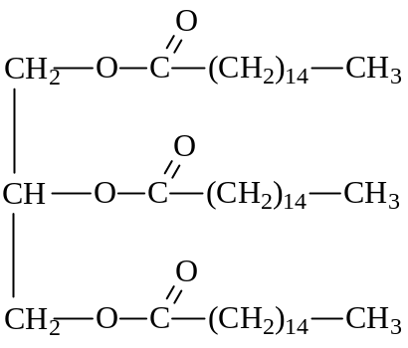

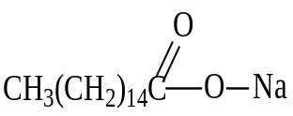 (i) Construct the structural formula of the soap formed from glyceryl tripalmitate. 1

(ii) Identify the special type of mixture which forms when the soap is shaken with
glyceryl tripalmitate 1

The mixture of soap, water and glyceryl tripalmitate would form an emulsion.

(iii) Other than glyceryl tripalmitate identify another fat or oil which can be used
to make soap. 1

Tallow, lard, coconut oil, olive oil, rice bran oil, etc. (Common or chemical name)
► Not palm oil

(iv) Compare the environmental impacts of the use of soaps and non–phosphate
detergents. 2

The use of soap has a low impact on the environment because of their biodegradability.
(1 mark)

Detergents have a higher impact on the environment because they are less biodegradable and
they contain other ingredients (e.g. zeolites) which can cause harm to aquatic ecosystems.
(1 mark)

Outcomes ~ H8, 11

(b) In his quest for the BHP Science Prize, Ken Chemiski plans to prepare sulfuric acid using this
relatively simple apparatus. Sulfur is burned in a crucible and the gas flow is forced through the
apparatus using a vacuum pump.
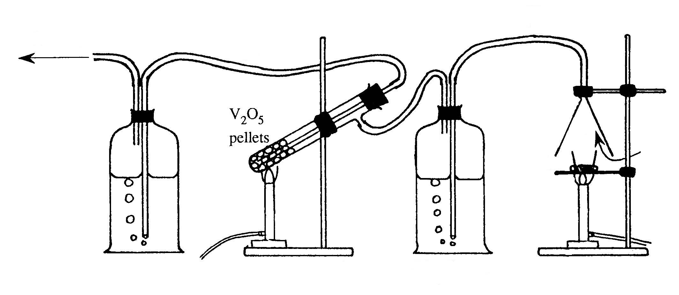
X
Z
concentrated
H₂SO₄
crucible of
burning sulfur
air
Y
to vacuum
pump
Vessels A and Z originally filled with
concentrated H₂SO₄
A
Z

(i) Evaluate the feasibility of Ken’s apparatus to produce sulfuric acid ignoring
safety issues 2
Ken’s apparatus is perfectly feasible as a small scale Contact Process.
The apparatus provides all the raw materials and conditions necessary to produce sulfuric acid.

Supporting evidence (1 mark) Judgement (1 mark)

(ii) Compare the gas composition in tube X with tube Y. 2

Tube X contains SO₂ and air. (1 mark) Tube Y contains SO₃. (1 mark)

(iii) Identify the role of the concentrated sulfuric acid in vessel A 1

The concentrated H₂SO₄ dehydrates the air before it reaches the V₂O₅.

(iv) Construct a chemical equation for the reaction of gas Y as it bubbles through vessel Z. 1

SO₃ _{(g)} + H₂SO₄ _{(l)} → H₂S₂O₇ _{(l)}

(c) Chlorine gas can be prepared industrially by this equilibrium reaction…

4HCl _{(g)} + O₂ _{(g)} 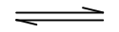 2Cl₂ _{(g)} + 2H₂O _{(g)}

An industrial chemist performs a small scale synthesis of this reaction in a two litre stainless steel tank and records this data…

 | HCl | O₂ | Cl₂ | H₂O
Initial moles | 0.548 | 0.625 | 0 | 0
Final moles at equilibrium | 0.200 | 0.538 | 0.174 | 0.174

(i) Calculate the equilibrium constant from the data. 3
[HCl] = 0.200 mol ÷ 2.00 L = 0.100 mol L ^{– 1}
Conversion from
moles to mol/L
(1 mark)
[O₂] = 0.538 mol ÷ 2.00 L = 0.269 mol L ^{– 1}
[Cl₂] = 0.174 mol ÷ 2.00 L = 0.0870 mol L ^{– 1}
[H₂O] = 0.174 mol ÷ 2.00 L = 0.0870 mol L ^{– 1}

K_{eq} = [Cl₂]² × [H₂O]²
[HCl]⁴ × [O₂]
K_{eq} expression (1 mark)

= (0.0870)² × (0.0870)²
(0.100)⁴ × (0.269)
Evaluation of K_{eq} (1 mark)
= 2.13

(ii) Identify how the value of the equilibrium constant could be changed. 1

The only factor that changes the value of the K_{eq} is temperature.
(iii) Explain, using Le Châtelier’s principle, how a change in volume will affect the
equilibrium. 2
The reaction equation shows the change in the gas volumes…

4 vol HCl + 1 vol O₂ 2 vol Cl₂ + 2 vol H₂O

According to Le Châtelier’s principle, a reduction in volume (realised by a increase in pressure) would shift the equilibrium to the right or vice versa. (2 marks)

(iv) Calculate the theoretical volume of chlorine produced at 25°C and 100 kPa, if the
reaction went to completion. 2
HCl is the limiting reactant.

Moles Cl₂ = ½ moles HCl = ½ × 0.548 mol = 0.274 mol (1 mark)

Volume Cl₂ = n × 24.79 L mol ^{– 1} = 0.274 mol × 24.79 L mol ^{– 1} = 6.79 L (1 mark)

(d) Kaipara Harbour has a surrounding population of 75,000 with a mixed economy including dairy
farming, market gardens, commercial prawn trawling in the harbour and offshore tuna fishing.
Three companies have expressed interest in building a sodium hydroxide production facility at
Pouto located in Kaipara Harbour.

HGCL Ltd. has plans for a mercury process plant; Mem-chlor-tech is proposing a membrane process plant;
and Chlorox Industries has plans for a diaphragm process plant.

Imagine you are an Environmental Chemist for the Kaipara Regional Planning Authority and have been given the task of writing an environmental risk assessment comparing all three plant proposals and making recommendations as to which proposal should be approved. 6


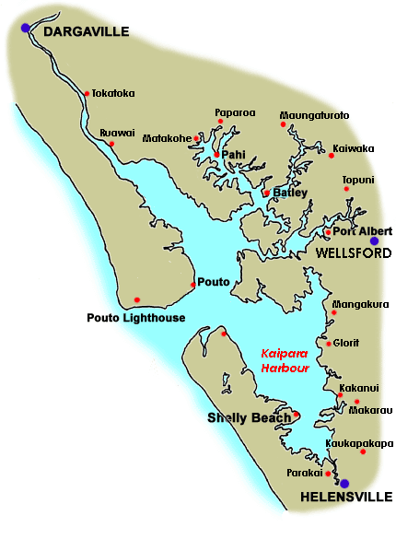
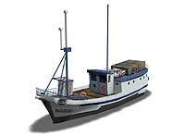
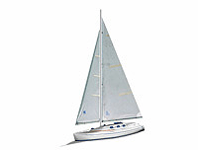

Pacific Ocean
Proposed site of NaOH factory

►
Environmental Risk Assessment
for
Proposed Sodium Hydroxide Plant at Puoto

All three proposed sodium hydroxide plants pose environmental risks to Kaipara Harbour. Outlined below are the specific risks associated with the method of production…

HGCL Ltd. ~ mercury process
This process uses sizeable amounts of liquid mercury in the production process.

- Mercury can and does escape from plants. Escaped mercury can be converted into
dimethyl mercury by marine micro-organisms. Dimethyl mercury readily enters the
food chain and bio-accumulates in higher organisms, e.g. tuna and man.
Japan has banned the use of mercury process plants due to their inherent toxic hazards.

- Hydrogen gas is a by-product of the process and poses explosive risk.

- Leakage of caustic sodium hydroxide is a possibility.

Mem-chlor-tech ~ membrane process

This process is the most modern having undergone continuous development since the 1980s.

- The membrane process is ‘clean’ with no inherent environmental hazards.

- Hydrogen gas is a by-product of the process and poses explosive risk.

- Leakage of caustic sodium hydroxide is a possibility.

Chlorox Industries ~ diaphragm process
This process makes use of asbestos as a separator between the electrodes.

- Asbestos is considered a high risk to workers and the surrounding community.
The asbestos is routinely replaced during periodic maintenance and strict protocols must be followed in its handling and disposal.
- Hydrogen gas is a by-product of the process and poses explosive risk.

- Leakage of caustic sodium hydroxide is a possibility.

RECOMMENDATION

(1) Mem-chlor-tech’s membrane plant poses a manageable risk and should be considered for approval.
(2) The proposals of HGCL Ltd. and Chlorox Industries should be rejected due to significant inherent environmental risks.

Risks

Description of mercury risk (1 mark)
Description of asbestos risk (1 mark)
Description of hydrogen risk (1 mark)
Description of sodium hydroxide risk (1 mark)
Citing hydrogen and sodium hydroxide as common to all processes (1 mark)
Recommendation

Recommend Mem-chlor-tech (1 mark)

